Use citrus peels to start seeds

[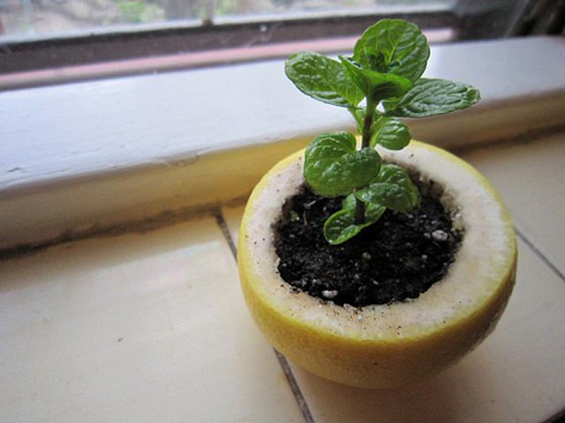](https://balconygardenweb-lhnfx0beomqvnhspx.netdna-ssl.com/wp-content/uploads/2016/06/Citrus-Peel-Starter-Pot2.jpg)

Just poke a hole in the bottom of the peel for drainage, fill it with potting soil, then sow seed and sprinkle some water. When the seedling is ready for transplant, plant it directly in a garden or in a container with the peel. The peel will decompose and nourish the young plant as it grows.